Shuzworld – Shanghai production facility

To: Cynthia Crowninshield

**From:** Aaron Camacho, Operations Consultant

**Subject:** Shuzworld’s Improvements

**Date:** January 20th 2014

**Distribution Pattern Assignment Tool**

The tool used to find the optimal distribution pattern was “Transportation” in Excel OM. The tool was chosen for its increased reliability over other models such as the ‘Northwest-Corner Rule’ and the ‘Intuitive Lowest Cost Method’. Each of these models provided a plausible total cost but it was impossible to tell if it was the lowest. Whereas, the “Transportation” tool in Excel OM is able to calculate all variables resulting in the minimum total cost possible.

**Reliability of the Computer-driven Shoe Machines**

Current Reliability if the computer-driven shoe machines is at 75.68 percent. A 25 percent chance that one of the machines will breakdown, thus stopping all other production, is a percentage that needs to be decreased. By decreasing the chance that one of the machines will breakdown the “Casual Deck Shoe” line will continue to meet production quotas and demand.

**Ways to Increase Reliability**

There are two main ways to increase reliability in the computer-driven shoe machines. (1) Improving individual components of the system, which can include purchasing backup unit of equal quality (i.e. redundancy), and; (2) Doing preventative maintenance.

First, I recommend that a backup unit of equal quality be purchased to supply redundancy to machine number one. By having a backup unit of equal quality for machine number one total system reliability will be increased to 87.78 percent.

Second, the Shanghai plant has two options at the moment: (1) Do preventative maintenance or (2) Do breakdown maintenance, run it until it breaks then fix it. A comparative analysis between the preventative maintenance cost and the failure rate and frequency can be done. This would give you the cheapest and perhaps the optimal route. However, if you own a car you may know the difference in the crisis level from an oil change to being broken down in the middle of a deserted desert. Preventative maintenance though it can be costly, get in the way of production and often be thought of as a ‘fix it whether or not it is broken’ approach increases reliability by preventing a breakdown. Everyone knows that a little preventative maintenance can add years of working operation. It is my recommendation that preventative maintenance be used.

**Tool Used to Make Decision**

The “Reliability” tool was used to determine the best machine to pair an identical unit with. However, many modifications were used to increase the reliability and ease of calculating with in the tool. With the reliability tool I built only the current reliability for each machine needs to be entered and the best available option is highlighted in green. There is no need to place and switch zeros around in the “backup” row until the optimal system reliability is found. However, the reliability tool and my personal model can both be used to find the same result. Using a model increases reliability by decreasing the chances for mathematical errors.

**Optimum Number of Shoelaces**

**Recommendation**

The optimal amount of shoelaces to order is 27,386. At this optimal unit order point the setup/order cost and in the holding cost intersect on the “Cost vs. Quantity” graph found in the attached excel document. This intersection indicates the optimal, which means the least costly, balance between ordering to many and too little shoelaces at once. Ordering 27,386 shoelaces will keep an average inventory of 13,693. Ten orders should be placed a year at the optimal reorder point (ROP) which is calculated as “(demand per a day) x (lead time for a new order in days) = ROP. With this configuration the holding and order cost will be at the optimal number of $1,369.31 each. It is important to note that the EOQ model assumes that we will never run out of stock. This is not very realistic in a real world application. Therefore, a safety stock should be applied to the total amount of shoelaces to be ordered. A safety stock is some quantity over the optimal order amount that you feel comfortable committing to. A good starting point could be between 5-10 percent of the optimal order amount.

**Economic Order Quantity**

The economic order quantity model relates to the shoelace problem for five reasons. (1) The demand is know and constant; (2) the receipt of inventory is instantaneous and complete whereas the EPQ model inventory comes over a period of time. (3) As far as we know quantity discounts are not available to us. (4) The only variable costs are set/order costs and holding costs, and; (5) Stock outs are assumed to be completely avoidable. However, there is one more thing that would be need to make the EOQ model more beneficial and applicable to this situation which is the lead time and the number of working days in a year. With these two variables an optimal reorder point could be established.

**Tool Used to Make Decision**

The in decision analysis tool used was “Inventory – Economic Order Quantity” in Excel OM. The tool was chosen because it best fit the details of the problem at hand. Meaning there is no assumed quantity discount and the receipt of inventory is instantaneous and not coming over a period of time like it would in the “Production Inventory Model”. Also, the tool was chosen for its ability to decrease human error in the calculations.

**Waiting-Line Systems**

**One-Cashier vs. Two-Cashier Comparison**

Below in figure 1 you will find a step-by-step analysis between one-cashier and two-cashiers. As you will see the idle time that cashiers will experience will increase from 50 percent to 75 percent (average server utilization). Also, with two cashiers customers will be moved through the store more quickly which is denoted in the decrease of “average number of customers in the queue”, “Average number of customers in the system”, “Average time in the queue”, “Average time in the system” and the probability (% of time) system is empty”.

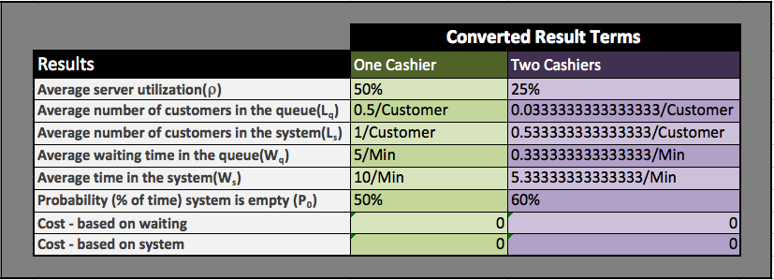

Figure 1: One-Cashier vs. Two-Cashier Comparison

**Recommendation**

It is my recommendation that the store use only one cashier. It is true that having two cashiers would move patrons through the store faster however, having two cashiers does not equate to increased revenue. In fact, having to cashiers would decrease the amount of net profit gained by the retail stores due to increased and unnecessary labor costs at this point in time. The justification for one-cashier is also based on the fact the average server utilization of 50 percent, average number of customers in the queue”, “Average number of customers in the system” and the “Average time in the queue” is well within industry customer service standards. If demand and store traffic increase a second cashier could be considered. However, at the moment an average server utilization percent of 25 is too low to justify the benefits over the cost of having two cashiers.

**Tool Used to Make Decision**

The in decision analysis tool used was “Waiting-Lines – Single Channel Model & Multiple Channel Model”. It was used to decrease the chance for error and the time needed to calculate mathematical solutions. Though each of the calculations could have been done by hand it would have taken much longer and the chance that I may have made a mistake would have been greatly increased. Also, the other two models available, constant service time model and limited population model are more applicable to an automated carwash where service is always available and a manufacturing facility respectfully.